**Nanoscopic studies of domain structure dynamics in ferroelectric La:HfO2 capacitors** [P. Buragohain](http://aip.scitation.org/author/Buragohain%2C+P), [C. Richter](http://aip.scitation.org/author/Richter%2C+C), [T. Schenk](http://aip.scitation.org/author/Schenk%2C+T), [H. Lu](http://aip.scitation.org/author/Lu%2C+H), [T. Mikolajick](http://aip.scitation.org/author/Mikolajick%2C+T), [U. Schroeder](http://aip.scitation.org/author/Schroeder%2C+U), and [A. Gruverman](http://aip.scitation.org/author/Gruverman%2C+A)

Citation: Appl. Phys. Lett.**112**, 222901 (2018); doi: 10.1063/1.5030562 View online: <https://doi.org/10.1063/1.5030562>  
View Table of Contents: <http://aip.scitation.org/toc/apl/112/22>  
Published by the [American Institute of Physics](http://aip.scitation.org/publisher/)

**Articles you may be interested in**   
[Silicon doped hafnium oxide (HSO) and hafnium zirconium oxide (HZO) based FeFET: A material relation to device physics](http://aip.scitation.org/doi/abs/10.1063/1.5029324)   
[Applied Physic](http://aip.scitation.org/doi/abs/10.1063/1.5029324)s Letters **112**, 222903 (2018); 10.1063/1.5029324   
[Evolution of ferroelectric HfO2 in ultrathin region down to 3nm](http://aip.scitation.org/doi/abs/10.1063/1.5017094)   
Applied Physics Letters **112**, 102902 (2018); 10.1063/1.5017094   
[Interplay between ferroelectric and resistive switching in doped crystalline HfO2](http://aip.scitation.org/doi/abs/10.1063/1.5015985)   
Journal of Applied Physics **123**, 134102 (2018); 10.1063/1.5015985   
[Ferroelectricity in epitaxial Y-doped HfO2 thin film integrated on Si substrate](http://aip.scitation.org/doi/abs/10.1063/1.5020688)   
Applied Physics Letters **112**, 202901 (2018); 10.1063/1.5020688   
[On the relationship between field cycling and imprint in ferroelectric Hf0.5Zr0.5O2](http://aip.scitation.org/doi/abs/10.1063/1.5026424)   
Journal of Applied Physics **123**, 204101 (2018); 10.1063/1.5026424   
[Ferroelectricity in hafnium oxide thin films](http://aip.scitation.org/doi/abs/10.1063/1.3634052)   
[Applied Physics Letters](http://aip.scitation.org/doi/abs/10.1063/1.3634052) **[99](http://aip.scitation.org/doi/abs/10.1063/1.3634052)**[, 102903 (2011](http://aip.scitation.org/doi/abs/10.1063/1.3634052)); 10.1063/1.3634052



Reuse of AIP Publishing content is subject to the terms at: <a href="https://publishing.aip.org/authors/rights-and-permissions">https://publishing.aip.org/authors/rights-and-permissions</a>. Downloaded to: 143.215.23.187 on 07 November 2018, At: 18:58

APPLIED PHYSICS LETTERS 112, 222901 (2018) 

[Nanoscopic studies of domain structure dynamics in ferroelectric La:HfO2 capacitors](https://doi.org/10.1063/1.5030562)

P. Buragohain,1C. Richter,2T. Schenk,2H. Lu,1T. Mikolajick,2,3U. Schroeder,2 and A. Gruverman1,a)   
1Department of Physics and Astronomy, University of Nebraska, Lincoln, Nebraska 68588, USA 2NaMLab gGmbH/TU Dresden, Noethnitzer Str. 64, 01187 Dresden, Germany   
3Institute of Semiconductors and Microsystems, TU Dresden, 01062 Dresden, Germany

(Received 22 March 2018; accepted 12 May 2018; published online 31 May 2018)

Visualization of domain structure evolution under an electrical bias has been carried out in ferroelectric La:HfO2 capacitors by a combination of Piezoresponse Force Microscopy (PFM) and pulse switching techniques to study the nanoscopic mechanism of polarization reversal and the wake-up process. It has been directly shown that the main mechanism behind the transformation of the polarization hysteretic behavior and an increase in the remanent polarization value upon the alternating current cycling is electrically induced domain de-pinning. PFM imaging and local spec-troscopy revealed asymmetric switching in the La:HfO2 capacitors due to a significant imprint likely caused by the different boundary conditions at the top and bottom interfaces. Domain switch-ing kinetics can be well-described by the nucleation limited switching model characterized by a broad distribution of the local switching times. It has been found that the domain velocity varies significantly throughout the switching process indicating strong interaction with structural defects.

Published by AIP Publishing. <https://doi.org/10.1063/1.5030562>

The discovery of ferroelectricity (FE) in hafnium oxide (HfO2) based thin films1opens a possibility of overcoming significant problems associated with application of perovskite ferroelectrics in electronic devices, such as poor CMOS com-patibility, small bandgap, and low resistance to hydrogen.2 Robust polarization and high switching endurance make them promising candidates for ferroelectric memory and logic devi-ces.3,4This application potential has been emphasized by the development of functional HfO2-based ferroelectric field effect transistors5and a recent demonstration of polarization-controlled tunneling electroresistance effect in ultrathin HfO2-based tunnel junctions.6,7Realization of the full potential of the HfO2-based films requires comprehensive studies of the mechanism of polarization reversal and the impact of micro-structure on their switching properties. One of the characteris-tic features of these materials is the so-called “wake-up”effect8–11[also termed as alternating current (AC) training12], in which a polarization hysteresis loop, initially constricted, opens up upon AC field cycling exhibiting a significantly increased remanent polarization. Several groups have reported that the underlying cause for this effect might be a redistribu-tion of mobile ions13and oxygen vacancies,14–16or a phase transition from a non-FE to a FE phase.17,18In spite of active studies by means of integral electrical methods, such as polar-ization hysteresis and transient current measurements,19there is dearth of information on the kinetics of domain nucleation and wall motion during polarization reversal in HfO2-based films. Here, we use a combination of high-resolution domain imaging and local switching spectroscopy by Piezoresponse Force Microscopy (PFM) in conjunction with pulse switching measurements to get a nanoscopic insight into the mechanism

a)Author to whom correspondence should be addressed: [alexei_gruverman@ unl.edu](mailto:alexei_gruverman@unl.edu)

of the wake-up phenomenon and switching behavior of La-doped HfO2 (La:HfO2) ferroelectric capacitors. We find that the AC field cycling leads to de-pinning of domains, resulting in an increase in the remanent polarization. It is also shown that polarization reversal behavior is consistent with the nucleation-limited switching model (NLS).20

capacitors fabricated on Si substrates by atomic layer deposi-Experiments have been carried out using 125 � 110 lm2

tion (ALD).21A stack of 10-nm-thick La:HfO2 film sand-wiched between TiN electrodes has been annealed in N2 atmosphere at 800�C for 20 s. Subsequently, 10-nm-thick Ti and 25-nm-thick Pt layers were evaporated on TiN and pat-terned into top electrode pads.21   
 In these studies, a microscopic external probe has been used to apply the poling voltage pulses and the AC voltage to the top electrode during the PFM and pulse switching mea-surements [Fig. 1(a)], while the PFM cantilevers have been used to detect the local electromechanical response of the samples visualizing the domain structure and acquire the sur-face topography maps [Fig. 1(b)]. This approach allows alle-viation of the problem associated with the quick deterioration of the tip-sample contact resistance as well as with the strong electrostatic effect on the measured PFM signal.22PFM imag-ing and local switching spectroscopy measurements have been carried out using a commercial atomic force microscope system (MFP-3D, Asylum Research) with single-crystalline diamond tips (D80, K-Tek Nanotechnology) and employing a 350 kHz AC voltage with the 0.5 V amplitude. Voltage pulses were applied using a Keysight 33621A arbitrary waveform generator, and the signals were recorded by a Tektronix TDS 3014B oscilloscope.

Conventional polarization-voltage (P-V) hysteresis loops have been obtained by integration of the transient current under application of a triangular voltage pulse. The pristine

|  |  |  |
| --- | --- | --- |
| 0003-6951/2018/112(22)/222901/5/$30.00 | 112, 222901-1 | Published by AIP Publishing. |

|  |  |  |
| --- | --- | --- |
| 222901-2 | Buragohain et al. | Appl. Phys. Lett. 112, 222901 (2018)  FIG. 1. (a) Optical microscopy photo of the 125 � 110 lm2La:HfO2 capaci-tors array showing the cantilever and an external microprobe on top of one of the capacitors. (b) Topographic image of the TiN top electrode using atomic force microscopy (AFM). (c) P-V hys-teresis loops and (d) I-V loops acquired from the La:HfO2 capacitor in the pris-tine state (red) and after 104cycles of AC training (black). (e), (f) PFM phase (e) and amplitude (f) of a pristine capacitor. |
|  | |

state of the La:HfO2 capacitors is characterized by a pinched hysteresis loop with a low value of remanent polarization [Fig. 1(c)], which is consistent with the earlier reported results.10,13,14,21Multiple switching peaks in the correspond-ing current-voltage (I-V) curve [Fig. 1(d)] can be attributed to a wide variability of the local pinning potential. PFM imaging of the pristine La:HfO2 capacitors reveals a polydomain struc-ture with an average domain size of several hundred nano-meters [Figs. 1(e) and 1(f)] and no correlation with any topographic features. To induce the wake-up process, the capacitors were subjected to 104cycles of AC training using rectangular voltage pulses of 63.5 V amplitude and 25 ls duration. As a result of this cyclic switching, the remanent polarization increased to about 25 lC/cm2while the transient current peaks merged into single switching peaks suggesting significant changes in the switching potential landscape.

To understand the underlying mechanism of the wake-up effect, the nanoscopic domain structure and its response to the applied electrical bias have been investigated by means of the PFM technique. Figures 2(a) and 2(b) show that the application of 63.0 V, 1 ms voltage pulses to the pristine capacitors results only in a minimal change in the domain configuration suggesting strong pinning of domains, which is consistent with the low remanent polarization value detected from the P-V loop measurements. The switchability of the capacitors dramatically changes after they were sub-jected to 104cycles of AC training as is illustrated by the PFM images in Figs. 2(c) and 2(d). It can be seen that the domain structure changes completely in response to the application of the 63.0 V, 1 ms poling pulses, indicating increased switchability of domains as a result of the wake-up process. This result, in conjunction with X-ray diffraction results indicating a FE phase volume fraction of almost 90% in the studied films,21suggests that the increase in the rema-nent polarization upon AC cycling is mostly due to domain de-pinning, even though some contribution from the field-induced phase transformation cannot be ruled out.18,21Note, that the de-pinning process is not symmetric: some of the domains with the downward polarization were still pinned

after AC cycling as they could not be switched upward by the application of a �3 V pulse [Fig. 2(c)], while switching to the downward direction by a 3 V pulse was complete [Fig. 2(d)]. It can be assumed that this asymmetry is a result of the asymmetric boundary conditions at the top and bottom inter-faces due to the fabrication route. The bottom electrode is subject to oxidizing species during the ALD process, which is not the case for the top electrode, and a Ti-O(-N) layer has been shown to form under similar conditions also due to the thermal energy imposed by the crystallization anneal.23–25 Another feature worth mentioning is strong spatial variabil-ity of the local switching parameters at the nanoscale level likely caused by structural imperfections associated with polycrystalline nature of the La:HfO2 capacitors.

Analysis of the PFM images in Figs. 2(a) and 2(b) allows us to select different representative regions to illus-trate this point. Shown in Figs. 2(e)–2(g) are the local PFM hysteresis loops for the pristine state (red curves) and after AC cycling (blue curves) for the three locations marked in Fig. 2(a). Location 1 exhibits symmetric coercive voltages and good switchability before and after the wake-up process [Fig. 2(e)], which is consistent with the switching behavior revealed by the PFM imaging in Figs. 2(a)–2(d). Location 2, however, shows strong negative imprint in the pristine state [Fig. 2(f)] consistent with the pinned downward polarization state. This imprint disappears after AC cycling suggesting domain de-pinning, which can be also seen in the PFM phase image [Fig. 2(d)]. In location 3, no evidence of the ferroelec-tric behavior can be observed even after the wake-up process [Fig. 2(g)], which could be a signature of a residual non-ferroelectric phase. Both findings, an initial local imprint that disappears during AC cycling and the existence of non-FE phase fractions are consistent with earlier reports based on first-order reversal curves13and Rietveld refinement.21 The switching spectroscopy PFM (SS-PFM) approach26 provides further insight into the spatial variability of the local switching parameters. Two-dimensional maps of the local imprint bias have been generated by acquiring local hysteresis loops at each point while rastering the 500 � 500 nm2region

|  |  |  |
| --- | --- | --- |
| 222901-3 | Buragohain et al. | Appl. Phys. Lett. 112, 222901 (2018)  FIG. 2. (a)–(d) Comparison of capaci-tor switchability in the pristine state and after the wake-up process. PFM ampli-tude (top) and phase (bottom) images of a La:HfO2 capacitor after application of a 63V, 1 ms pulse in pristine state (a), (b) and after application of 104cycles of AC training (c), (d). Bright (dark) color in the phase images corresponds to downward (upward) polarization. (e)–(g) Local PFM hysteresis loops acquired in location 1 (e), 2 (f), and 3 (g) marked with red dots in (a) for pris-tine (red) and after the wake-up process (black). |
|  | |

on the top electrode surface of the capacitors in the pristine state [Fig. 3(a)] and after the wake-up process [Fig. 3(b)]. Histogram analysis of the acquired maps reveals the reduction in the magnitude of imprint upon AC field cycling [Fig. 3(c)], even though about 90% of the imaged area still exhibits some negative imprint after the wake-up process. The SS-PFM maps and the corresponding histograms further corroborate the switching behavior seen in the PFM poling data (Fig. 2).

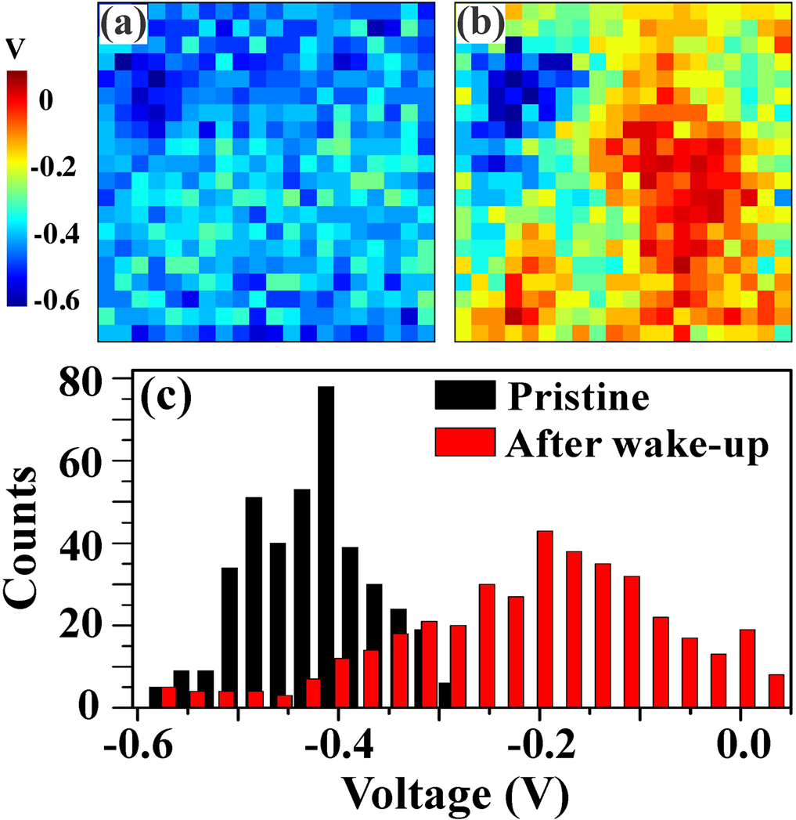

FIG. 3. (a), (b) 500 � 500 nm2imprint maps obtained by PFM switching spectroscopy using a 20 � 20 grid for the pristine state (a) and after wake-up (b). (c) Comparison of histograms of the imprint maps in (a) and (b) illustrat-ing a change in the overall imprint bias after the wake-up process.

The spatial variations of the imprint and coercive bias give a sense of the expected domain kinetics in the La:HfO2 capacitors during polarization reversal, which has been investigated by means of the stroboscopic PFM approach.27 In this approach, a sequence of input voltage pulses of incre-mentally increasing duration (each one shorter than the total switching time) is applied to a capacitor inducing partial polarization switching. PFM imaging of the resulting domain pattern representing a certain stage of polarization reversal is performed after each pulse. Figure 4(a) shows PFM images of instantaneous domain configurations developing in the previously AC-trained La:HfO2 capacitors at different stages of polarization reversal process induced by 4 V switching pulses. It can be seen that switching occurs through the side-wise expansion of the residual (pinned) domains of the corre-sponding polarity that have not been removed during the wake-up process as well as via nucleation and growth of new domains. By analyzing the space-time dependence of the domain expansion in the PFM snapshots, we were able to estimate the lateral domain wall (DW) velocity. It was found that the DW velocity varied depending on the azimuthal direction and was not constant throughout the switching pro-cess suggesting a strong impact of structural defects, such as grain boundaries. This hypothesis is supported by the fact that the size of the growing domains reaches values of up to 300 nm, which is larger than the average grain size (�30–50 nm), implying that the DWs move across several grain boundaries before annihilation by domain coalescence. Figure 4(b) shows a representative plot of the variations in the DW velocity as a function of time. The maximum veloc-ity measured is about 0.15 m/s, which is two orders of mag-nitude slower than the velocities observed in Pb(Zr,Ti)O3 capacitors for the same ratio of the applied field to the coer-cive field.27,28This low DW velocity seems to be consistent

|  |  |  |
| --- | --- | --- |
| 222901-4 | Buragohain et al. | Appl. Phys. Lett. 112, 222901 (2018) |

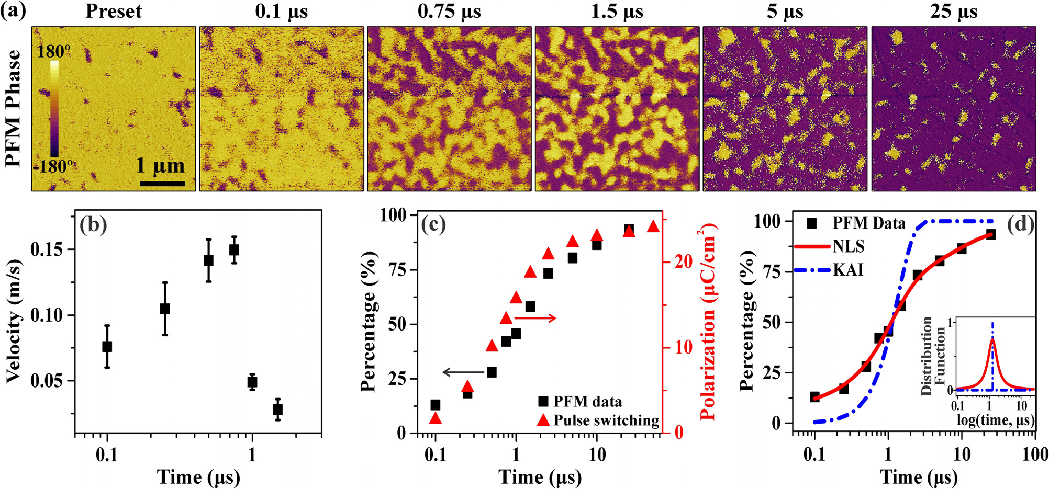

FIG. 4. (a) PFM phase images of instantaneous domain configurations developing at different stages of polarization reversal under application of 4.0 V pulses of increasing duration. (b) Time-dependent variations in domain wall velocity obtained by analyzing images in (a). (c) Comparison of experimental PFM data showing switched capacitor area as a function of time with the polarization obtained from pulse switching measurements. (d) Fitting of the PFM switching data by the KAI and NLS models. The inset shows the distribution functions for the corresponding models.

|  |  |  |  |  |  |  |  |  |
| --- | --- | --- | --- | --- | --- | --- | --- | --- |
| with recent reports on a small value of the Rayleigh constant | F logt | A | � |  | w |  | ; | (2) |
| measured in HfO2-based films.29Further dielectric spectros- | Ft0 ð | Þ ¼ | � | ð | log t0 � log t1 | Þ2þ w2 | �; |  |
| copy studies are necessary to clarify the mechanism of this |

significant speed discrepancy between HfO2-based and Pb(Zr,Ti)O3 films.

To quantify the domain switching kinetics, a time dependence of the switched capacitor volume fraction has been obtained by image analysis of the PFM data and plot-ting the obtained results as a function of the pulse duration. In addition, we performed pulse switching measurements using a four pulse waveform20to estimate the switched polarization as a function of the pulse duration to compare it with the PFM stroboscopic data. We found that the switched capacitor fraction with polarization along the direction of the applied field detected by PFM is proportional to the switched charge obtained by integration of current induced by pulse switching [Fig. 4(c)]. This allows us to treat the time-dependent PFM switching data, shown in Fig. 4(d), the same way as the switched polarization data and fit them with the well-known NLS model20

|  |  |  |  |  |  |  |  |
| --- | --- | --- | --- | --- | --- | --- | --- |
| DP tð Þ¼2Ps | ð1�1 | " 1� exp | (���n | ) # | �F logt0 | Þ�d logt0 | Þ; |

where A is a normalization constant, w is the half-width at half-maximum, and log t1 is the center of the distribution. When w approaches zero, F(x) becomes a delta function and we obtain the KAI model. Figure 4(d) shows that the NLS model provides a better fit to the experimental data than the KAI model, in agreement with previous reports that involved only pulse switching measurements.19,34   
 In conclusion, a combination of PFM imaging and mac-

|  |  |  |  |  |
| --- | --- | --- | --- | --- |
| roscopic | polarization | switching | measurements | provides |

direct evidence that the increase in the remanent polarization upon AC cycling in the La:HfO2 capacitors is mainly a result of electrically induced domain de-pinning although some contribution from the field-induced phase transformation cannot be ruled out. PFM poling experiments and switching spectroscopy reveal a broad variation in the local switching parameters likely caused by the asymmetry in the boundary conditions at the capacitors top and bottom interfaces and by the polycrystalline nature of the La:HfO2 films. The rema-nent (pinned) domains serve as the nucleation centers during polarization reversal and contribute to the switching behav-ior that is best described by the NLS model. The nanoscopic

(1) visualization of domain structure evolution during the wake-

where Ps is the spontaneous polarization, F(log t0) is a distri-bution function of the characteristic switching time, t0, and n is the effective dimension of domain growth (n¼ 2 in this case). The term in the square brackets in Eq. (1) represents the Kolmogorov-Avrami-Ishibashi (KAI)30–32switching model,

which does not consider spatial inhomogeneities in the film

up process as well as during polarization reversal will allow optimization of the switching behavior of the La:HfO2-based ferroelectric devices.

This work was supported by the National Science Foundation (NSF) through Materials Research Science and Engineering Center (MRSEC) under Grant No. DMR-

|  |  |  |  |  |  |  |
| --- | --- | --- | --- | --- | --- | --- |
| structure. To account for the polycrystalline nature of the | 1420645. | T.S. | gratefully | acknowledges | the | German |

La:HfO2 films and non-uniform internal potential landscape manifested in the imprint map [Fig. 3(b)], a Lorentzian distri-bution of the local switching times33is used in the NLS fitting

Research Foundation (Deutsche Forschungsgemeinschaft) for funding part of this research in the frame of the “Inferox”project (MI 1247/11-2).

|  |  |  |
| --- | --- | --- |
| 222901-5 | Buragohain et al. | Appl. Phys. Lett. 112, 222901 (2018) |

1T. S. Boescke, J. Mueller, D. Braeuhaus, U. Schroeder, and U. Boetgger, [Appl. Phys. Lett.](https://doi.org/10.1063/1.3634052) 99, 102903 (2011).

2M. H. Park, Y. H. Lee, H. J. Kim, Y. J. Kim, T. Moon, K. D. Kim, J. M€uller, A. Kersch, U. Schroeder, T. Mikolajick, and C. S. Hwang, [Adv. Mater.](https://doi.org/10.1002/adma.201404531) 27, 1811 (2015).

3J. F. Scott, Ferroelectric Memories (Springer, Berlin, 2000).

4See <http://www.itrs2.net/itrs-reports.html> for “International Technology Roadmap for Semiconductors-2013 Emerging Research Devices.”  
5J. M€uller, T. S. B€oscke, S. M€uller, E. Yurchuk, P. Polakowski, J. Paul, D. Martin, T. Schenk, K. Khullar, A. Kersch, W. Weinreich, S. Riedel, K. Seidel, A. Kumar, T. M. Arruda, S. V. Kalinin, T. Schl€osser, R. Boschke, R. van Bentum, U. Schr€oder, and T. Mikolajick, in IEEE International Electron Devices Meeting (2013), p. 10.8.1.

6A. Chernikova, M. Kozodaev, A. Markeev, D. Negrov, M. Spiridonov, S. Zarubin, O. Bak, P. Buragohain, H. Lu, E. Suvorova, A. Gruverman, and A. Zenkevich, [ACS Appl. Mater. Interfaces](https://doi.org/10.1021/acsami.5b11653) 8, 7232 (2016).

7S. Fujii, Y. Kamimuta, T. Ino, Y. Nakasaki, R. Takaishi, and M. Saitoh, in 2016 IEEE Symposium on VLSI Technology, Honolulu, USA, 14–16 June 2016 (IEEE, 2016), pp. 1–2.

8D. Zhou, J. Xu, Q. Li, Y. Guan, F. Cao, X. Dong, J. M€uller, T. Schenk, and U. Schroeder, [Appl. Phys. Lett.](https://doi.org/10.1063/1.4829064) 103, 192904 (2013).

9S. M€uller, C. Adelmann, A. Singh, S. Van Elshocht, U. Schroeder, and T. Mikolajick, [ECS J. Solid State Sci. Technol.](https://doi.org/10.1149/2.002301jss) 1, N123 (2012).

10T. Schenk, U. Schroeder, M. Pe�sic, M. Popovici, Y. V. Pershin, and T. Mikolajick, [ACS Appl. Mater. Interfaces](https://doi.org/10.1021/am504837r) 6, 19744 (2014).

11M. H. Park, H. J. Kim, Y. J. Kim, Y. H. Lee, T. Moon, K. D. Kim, S. D. Hyun, F. Fengler, U. Schroeder, and C. S. Hwang, [ACS Appl. Mater. Interfaces](https://doi.org/10.1021/acsami.6b03586) 8, 15466 (2016).

12M. Kohli, P. Muralt, and N. Setter, [Appl. Phys. Lett.](https://doi.org/10.1063/1.121554) 72, 3217 (1998). 13T. Schenk, M. Hoffmann, J. Ocker, M. Pe�sic, T. Mikolajick, and U. Schroeder, [ACS Appl. Mater. Interfaces](https://doi.org/10.1021/acsami.5b05773) 7, 20224 (2015).

14S. Starschich, S. Menzel, and U. B€ottger, [Appl. Phys. Lett.](https://doi.org/10.1063/1.4940370) 108, 032903 (2016).

15M. Pe�sic, F. P. G. Fengler, L. Larcher, A. Padovani, T. Schenk, E. D. Grimley, X. Sang, J. M. LeBeau, S. Slesazeck, U. Schroeder, and T. Mikolajick, [Adv. Funct. Mater.](https://doi.org/10.1002/adfm.201600590) 26, 4601 (2016).

16F. P. G. Fengler, M. Pe�sic, S. Starschich, T. Schneller, C. K€unneth, U. B€ottger, H. Mulaosmanovic, T. Schenk, M. H. Park, R. Nigon, P. Muralt,

T. Mikolajick, and U. Schroeder, [Adv. Electron. Mater.](https://doi.org/10.1002/aelm.201600505) 3, 1600505 (2017).

17M. H. Park, H. J. Kim, Y. J. Kim, Y. H. Lee, T. Moon, K. D. Kim, S. D. Hyun, and C. S. Hwang, [Appl. Phys. Lett.](https://doi.org/10.1063/1.4935588) 107, 192907 (2015).

18E. D. Grimley, T. Schenk, X. Sang, M. Pe�sic´, U. Schroeder, T. Mikolajick, and J. M. LeBeau, [Adv. Electron. Mater.](https://doi.org/10.1002/aelm.201600173) 2, 1600173 (2016).

19H. Mulaosmanovic, J. Ocker, S. M€uller, U. Schroeder, J. M€uller, P. Polakowski, S. Flachowsky, R. van Bentum, T. Mikolajick, and S. Slesazeck, [ACS Appl. Mater. Interfaces](https://doi.org/10.1021/acsami.6b13866) 9, 3792 (2017).

20A. K. Tagantsev, I. Stolichnov, N. Setter, J. S. Cross, and M. Tsukada, [Phys. Rev. B](https://doi.org/10.1103/PhysRevB.66.214109) 66, 214109 (2002).

21U. Schroeder, C. Richter, M. H. Park, T. Schenk, M. Pe�sic´, M. Hoffmann, F. Fengler, D. Pohl, B. Rellinghaus, C. Zhou, C.-C. Chung, J. Jones, and T. Mikolajick, [Inorg. Chem.](https://doi.org/10.1021/acs.inorgchem.7b03149) 57(5), 2752 (2018).

22S. V. Kalinin and D. A. Bonnell, [Phys. Rev. B](https://doi.org/10.1103/PhysRevB.65.125408) 65, 125408 (2002).

23U. Schroeder, W. Weinreich, E. Erben, J. Mueller, L. Wilde, J. Heitmann, R.

Agaiby, D. Zhou, G. Jegert, and A. Kersch, [ECS Trans.](https://doi.org/10.1149/1.3205070) 25(4), 357 (2009). 24W. Weinreich, R. Reiche, M. Lemberger, G. Jegert, J. M€uller, L. Wilde, S. Teichert, J. Heitmann, E. Erben, L. Oberbeck, U. Schr€oder, A. J. Bauer, and H. Ryssel, [Microelectron. Eng.](https://doi.org/10.1016/j.mee.2009.03.070) 86, 1826 (2009).

25W. Weinreich, T. Tauchnitz, P. Polakowski, M. Drescher, S. Riedel, J. Sundqvist, K. Seidel, M. Shirazi, S. D. Elliott, S. Ohsiek, E. Erben, and B. Trui, [J. Vac. Sci. Technol., A](https://doi.org/10.1116/1.4766281) 31, 01A123 (2013).

26P. Bintachitt, S. Trolier-McKinstry, K. Seal, S. Jesse, and S. V. Kalinin, [Appl. Phys. Lett.](https://doi.org/10.1063/1.3070543) 94, 042906 (2009).

27A. Gruverman, D. Wu, and J. F. Scott, [Phys. Rev. Lett.](https://doi.org/10.1103/PhysRevLett.100.097601) 100, 097601 (2008).

28A. Grigoriev, D.-H. Do, D. M. Kim, C.-B. Eom, B. Adams, E. M. Dufresne, and P. G. Evans, [Phys. Rev. Lett.](https://doi.org/10.1103/PhysRevLett.96.187601) 96, 187601 (2006).

29Y. Guan, D. Zhou, J. Xu, X. Liu, F. Cao, X. Dong, J. M€uller, T. Schenk, and U. Schroeder, [Phys. Status Solidi RRL](https://doi.org/10.1002/pssr.201510270) 9, 589 (2015).

30A. N. Kolmogorov, Izv. Akad. Nauk USSR, Ser. Math. 3, 355 (1937). 31M. Avrami, [J. Chem. Phys.](https://doi.org/10.1063/1.1750380) 7, 1103 (1939).

32Y. Ishibashi and Y. Takagi, [J. Phys. Soc. Jpn.](https://doi.org/10.1143/JPSJ.31.506) 31, 506 (1971).

33J. Y. Jo, H. S. Han, J.-G. Yoon, T. K. Song, S. H. Kim, and T. W. Noh, [Phys. Rev. Lett.](https://doi.org/10.1103/PhysRevLett.99.267602) 99, 267602 (2007).

34S. Mueller, S. R. Summerfelt, J. M€uller, U. Schroeder, and T. Mikolajick, [IEEE Electron Device Lett.](https://doi.org/10.1109/LED.2012.2204856) 33, 1300 (2012).